Project Design Phase
Proposed Solution Template
Date | 07 July 2026
Team ID | SWTID-2026-2247
Project Name | Emotion Detection and Learning Support Engine
Maximum Marks | 2 Marks

Proposed Solution Template:
Project team shall fill the following information in the proposed solution template.
S.No. | Parameter | Description
1. | Problem Statement  (Problem to be solved) | - Students in online/hybrid classrooms often experience confusion, boredom, stress, or disengagement that goes unnoticed until it shows up in poor grades or dropout.  - Existing e-learning platforms adapt only to quiz scores or time spent, not to how the learner actually feels, leaving struggling students without timely support.
2. | Idea / Solution  description | - An AI-powered Emotion Detection and Learning Support Engine that captures student emotional signals in real time through webcam (facial expression), microphone (voice tone), and chat/quiz text (sentiment).  - Classifies the emotional state (confused, bored, stressed, engaged) and feeds it into an adaptive learning engine that personalizes content difficulty, suggests breaks, and alerts teachers/parents instantly.  - Integrates directly into existing LMS and video-conferencing tools rather than requiring a separate app.
3. | Novelty / Uniqueness | - Multimodal real-time emotion fusion (facial + voice + text) instead of relying on a single signal.  - Direct plug-in integration into existing classroom tools (LMS, Zoom, Teams) rather than a standalone platform.  - Closed-loop adaptive learning: emotional state directly drives content/pace changes, not just analytics dashboards.  - Privacy-first design with encrypted data handling and edge-processing options suited for minors.
4. | Social Impact / Customer  Satisfaction | - Reduces student dropout and learning anxiety by catching struggles early.  - Empowers teachers with actionable, real-time insight instead of guesswork.  - Gives parents visibility into their child's emotional learning journey.  - Promotes inclusive education by supporting students reluctant to ask for help, improving overall well-being.
5. | Business Model  (Revenue Model) | - SaaS subscription for schools/institutions with per-student/per-classroom tiered licensing.  - Freemium model for individual tutors/small coaching centers with a premium analytics add-on.  - B2B2C partnerships with LMS providers (Google Classroom, Moodle) for bundled integration.  - Aggregated, anonymized insights/reporting offered as a premium add-on for institutions.
6. | Scalability of the  Solution | - Cloud-native microservices architecture (Docker + Kubernetes) scales from a single classroom to district/national level.  - Multi-language support for facial/voice/text emotion models enables expansion across regions.  - API-first design allows integration with any LMS/video platform for horizontal market growth.  - Modular AI models extend to new age groups, corporate training, and government literacy programs.

Solution Diagrams:

1. Solution Concept Overview
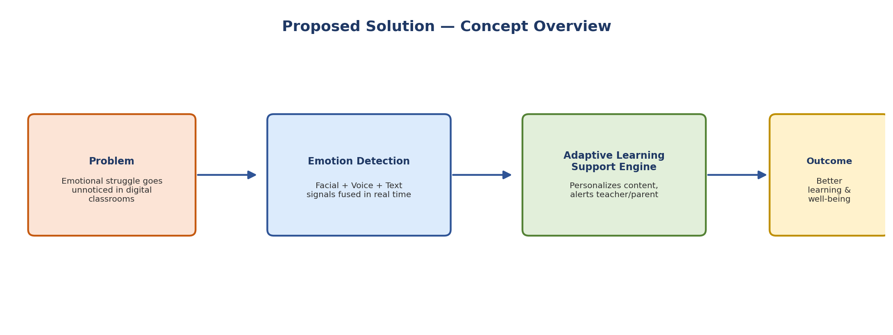

2. Scalability Path
